***ADVENTURE WORKS [Advanced] Problem Statement: -***

The AdventureWorks sales excel workbook captures all the details of a fictitious multinational manufacturing company called Adventure Works Cycles, including the details of customers, products, sales, territory, etc. Load the dataset into the PowerBI desktop and perform the following transformations to analyze and gain further insights into the company’s financial performance and profitability. Do all the necessary calculations and transformations using DAX functions or on Power query. We can use the file from the Adventure Works Intermediate.  
  
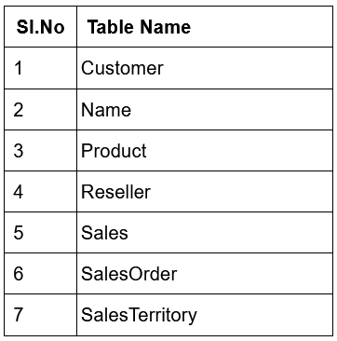  
  
1. Calculate total sales from accessories using filter function, Calculate().  
2. Create a new measure ‘Previous Year Sales’ using Time Intelligence DAX function, previousyear()  
3. Calculate Previous Month Sales as a new measure, in similar lines.  
4. Create New measures for ‘Quantity sold in last 3 months’ and ‘Profit for last 6 months’  
5. Using DAX functions, calculate YTD, MTD and QTD as well as YoY and QoQ and MoM  
6. Finally, create a report that includes all new calculated parameters with suitable visuals and   
 capture the insights.  
  
__________________________________________________________________________________  
  
***Solution: -***  
  
Loading the respective dataset namely, ‘AdventureWorks_Sale_3.xlsx’ via Excel Workbook under home or through power Query itself and loading a source, we get a look at all the tables available, we select all of the tables and load each of them into Power BI. Let’s follow proceeding with the same steps as the previous Intermediate. We proceed with the same Cleaning Steps in intermediate version of this project. As the Datasets are the same, I’m not listing those steps, because it should be self-explanatory at this final stage. Data Modeling and Cardinality etc.  
  
We have created a new Measures table named ‘Questions’ to insert all the measures to keep it neat and tidy.  
  
1. So, the first question, requires us to list the total sales of product listed as categories.  
 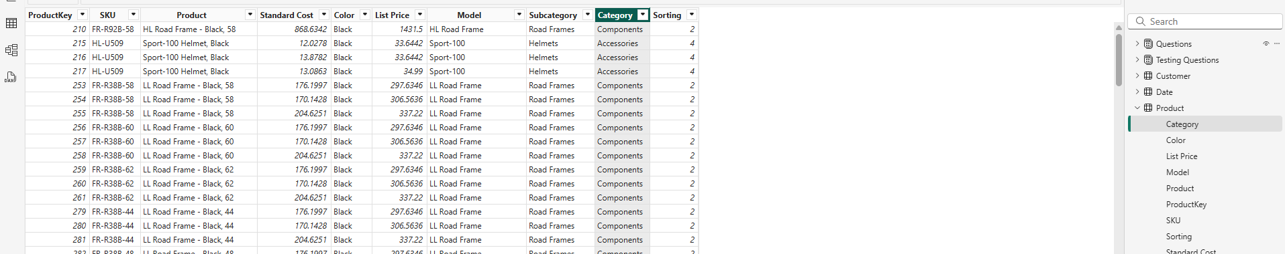  
this, is the category as Accessories so we need to create a Measure that gives us the total sales for Categories using CALCULATE() function.  
  
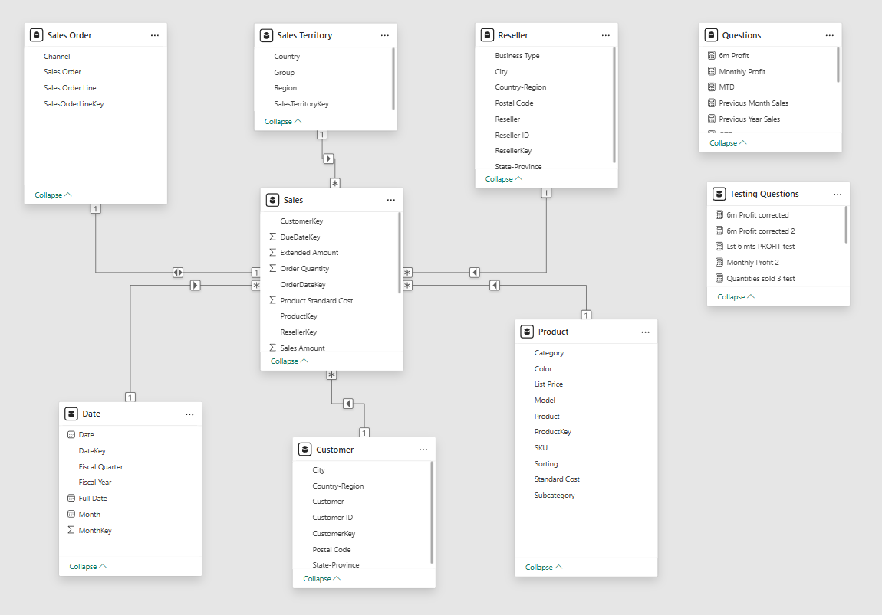  
Since, cardinality is, done as in Intermediate project steps, we form ‘auto detect’ or manual cardinality checking the primary and foreign keys of all the tables.  
  
here, testing questions and Questions are two separate tables used for the trial and error of the answer which may or may not be present in the final document of this project due to it being just a testing table.  
  
We use Calculate() function as shown that calculates Sum of sales amount with product category as “Accessories”, as shown below :  
   
  
  
2. Now, to create the previous year sales as a new measure, we are required to use time intelligence DAX function, previous year ()  
  
we can write the following code to achieve that:   
  
  
  
Or, we can also use another function called ‘same period last year’ to do so:  
  
**Previous_year_sales_SPLY = CALCULATE (SUM(Sales[Sales Amount]), SAMEPERIODLASTYEAR('Date'[Date].[Date]))**

The end part is absolutely necessary – the “.[Date]” part // this is extra information, because all (most) the other DAX before during my practice, requires me to use .[Date] after the mention of the Date table, don’t know if it’s a hierarchy issue or not, but regardless, I will use it.  
  
So, in order to display the above (correct i.e., “Previous year” function), we use a table, add in year from the Date table and add the aggregation of Sales from Sales table to understand it, then we add in our ‘Previous year sales’ measure to achieve the below result:  
  
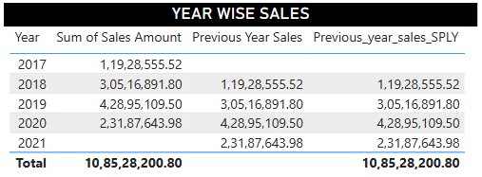  
  
The only difference between the two is that the latter shows a total, but the other does not, what I understood, it is because - PREVIOUSYEAR calculates the total for the entire previous year, while SAMEPERIODLASTYEAR calculates the total for the same period of the previous year, which is context-dependent. This difference in how they handle the context of the calculation explains why PREVIOUSYEAR may not display a total for the current period in the same way as SAMEPERIODLASTYEAR, same for the next question.  
  
3. Similarly, for ‘Previous Month Sales’, as a new measure, we will have to write the following code:  
  
  
  
Or, we can also use another function called ‘parallel period’ to do so:  
  
**Previous_Month_Sales_PP = CALCULATE(SUM(Sales[Sales Amount]), PARALLELPERIOD('Date'[Date].[Date], -1, MONTH))**

Which gives the following result:  
  
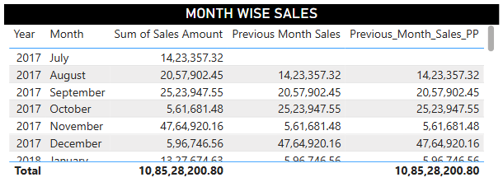  
  
4. Measure for the Quantity sold and Profits in the last 3 months, is a bit complicated as there was a solution file with me for this project but I did it myself then checked my steps if they matched and to my surprise, the solution was wrong, they had used DATEADD, which did nothing, it just printed or displayed the total qualities sold in the month that was 3 months ago in summary [the question hadn't asked about the monthly quantity sold 3 months ago, instead what they had asked is, **the total sum of quantity for the past 3 months**, hence it is incorrect]  
  
The total monthly profit must be individually calculated and I have done so (for both the solution and my self-corrected solution), in order to make the reader understand the problems I had faced while writing code and how I overcame them.  
  
This is the code for the total monthly Profit:   
  
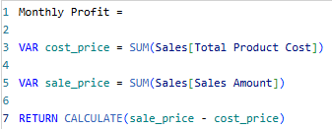  
  
Now, the incorrect code for the quantities sold: -  
  
  
Now, taking a table and adding the date year and month hierarchy and using it to show the total order quantity in the each month, with summation as the aggregation, we get this (incorrect):  
  
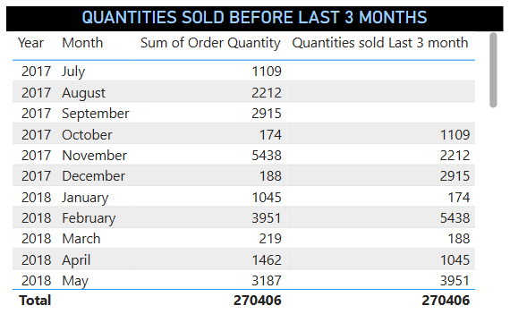  
which as discussed earlier, doesn’t show the true outcome to what the question desires but it is also a moment to learn how this can be used or implemented elsewhere.  
  
Similar code (incorrect) for the Profit for the past 3 months:  
  
  
  
Again, taking a table and adding the date year and month hierarchy and using it to show the total Sale Amount, the total Product cost and the profit in each month, and ofc 6m Profit with summation as the aggregation, we get this (incorrect):  
  
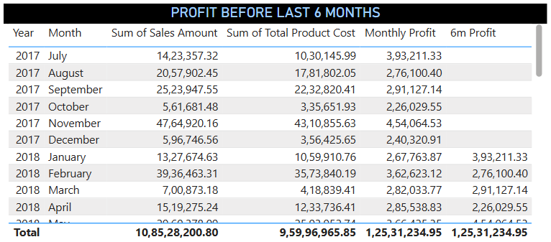  
  
Now, moving on, we will see how the actual (corrected) code runs for them:  
  
First, for total number of quantity sold:  
  
ignore the names for all the measures, it was a tedious task on my end to hit and trial these code by myself and run it. Anyways, here is the stark difference between the incorrect and corrected code:  
  
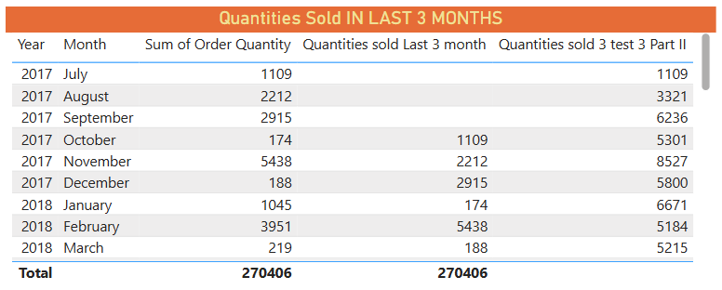  
See, how the end one sums up the total quantity for each month? Yes, exactly that is what the question has been asking.

And secondly, the total number of profits made for the last 6 months (corrected) code:  
  
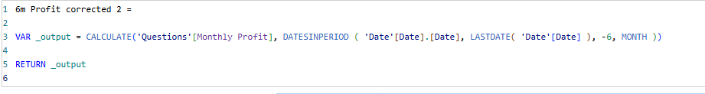  
  
and the table shows: -  
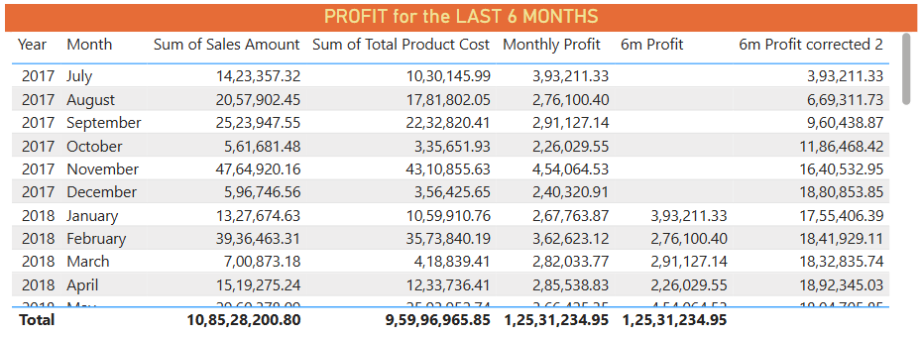  
Same way, it is fixed in its actual past 6 month records.  
  
Note: While tidying it up and using measures table, do not forget to name the appropriate names for the table, in order to not come across an error, it is the best practice.  
  
5. YTD: -  
   
 QTD: -  
   
  
Which we can capture insights using a matrix, taking date and sum of sales amount then YTD and   
then QTD as follows:  
  
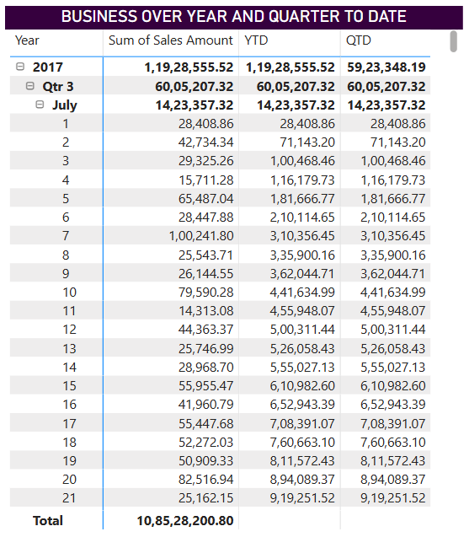

Now, MTD: -  
  
  
Which looks like this after adding sum of sales amount and MTD: -  
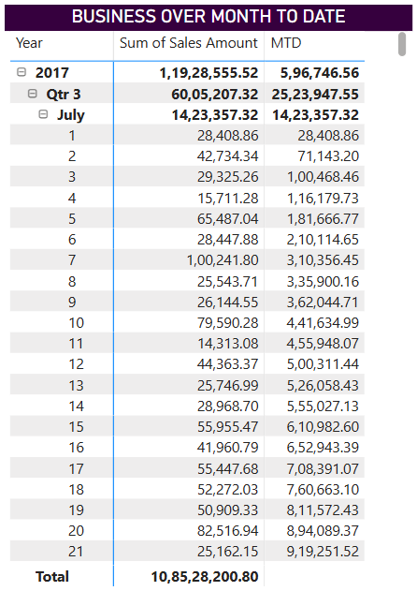

Finally, to calculate the Sales Year over Year, Quarter over Quarter and Month over Month (YoY and QoQ and MoM, respectively), we have to use Quick measure, also we could write the code ourselves but it would take time when we have such a good feature in Power BI named as Quick Measure, we can calculate it as follows:  
  
Report View 🡪 Quick Measures 🡪 Select a calculation 🡪 (Time intelligence Function - Year-over-year change or month over month or Quarter over Quarter etc.,) 🡪 Sum of Sales Amount (Base Value), Date from Date table (Date), 1 (Number of Periods – according to usage)  
  
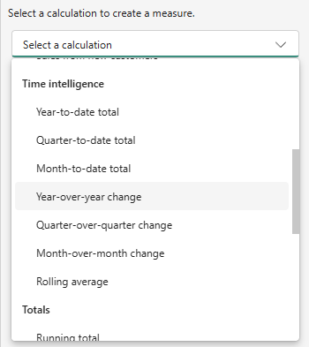  
  
And the code for it is pre-written as follows for YoY:  
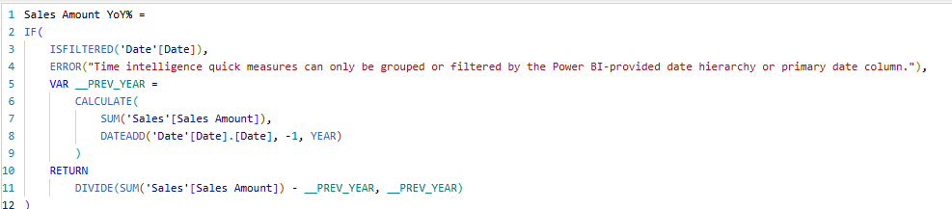

Do the same for QoQ and MoM and add them to a matrix table with date and sum of Sales Amount as follows:   
  
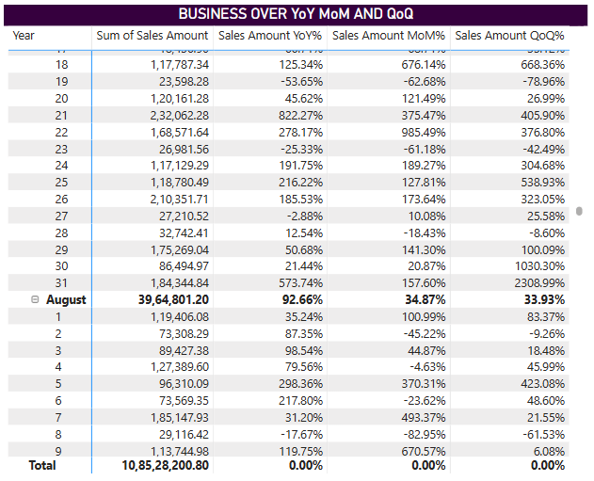  
  
Note that YTD refers to the period from the beginning of the current year up to the current date. For eg., if today’s date is May 27, 2025, YTD would represent the period from January 1 2025 to May 27, 2025, MTD would represent from May 1, 2025 to May 27, 2025 (current month) and QTD would represent from (current quarter up to current date) that is, April 1, 2025 to May 27, 2025.

That’s it.  
  
5. Or is it… We forgot the most important part, Display the visual data of everything: -  
  
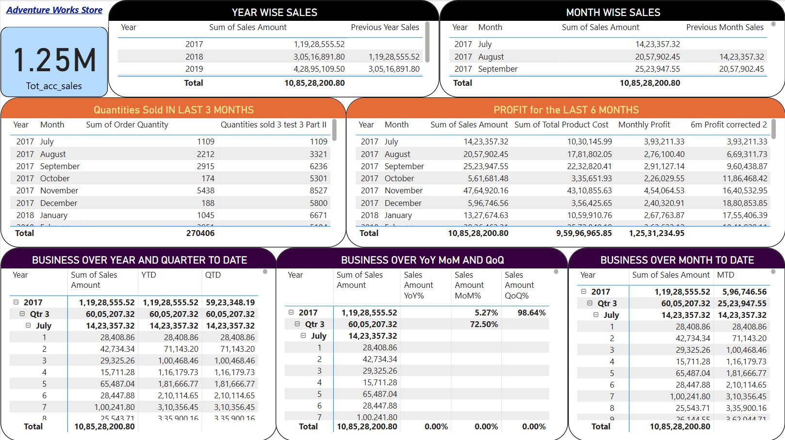

P.S. – Making calculated columns or using SUMX for profit is not helpful in this aggregation problems, I think it has something to do with it being a single dimension value, because when we visualise with the previous two, it shows blank. But anyways, my steps were helpful I hope so.

Project By – Bidarth Kr. Singh

*************************************************